PLANNING PERMIT APPLICATION NO. 5.2022.38.1
201492
2235680
Planning Permit Application Fee. $1307.60
Receipt No. 692933

ASSESSMENT REPORT:
No. of stat days at time of report: | 63 days as of 11/10/2022 (Further information submitted 26/07/2022)
Officer Direct or Indirect Conflict of Interest | No Council officers involved in the preparation or review of this report have any direct or indirect interest in the matter to which this report relates, in accordance with Section 80 (C) of the Local Government Act.

APPLICATION DETAILS:
Applicant: | KL Wightman
Application Received: | 28/04/2022
Proposal for “The Permit Allows”: | Development of (4) Dwellings and associated works
Property Address: | 15-17 Bowen Street, St Arnaud
Legal Description: | Land in Plan of Consolidation 364894K
Land Area: | 793 sqm
Existing Use: | Vacant
Zone: | GRZ1
Adjoining Zones: | GRZ1
Overlays: | Nil
Easements: | Yes; E-2 Drainage and Sewerage – no dwelling is built over the easement (garden/storage sheds only).
Covenants or Restrictions: | No covenants or Section 173 Agreement registered on title.
CHMP required: | No. The area is not in an area of cultural heritage sensitivity.
Is the site located in a Special Water Supply Catchment? | No
Permit Triggers: | Clause 32.08 (GRZ1) – A permit is required to construct multiple dwellings on a lot

PROPOSAL

The proposal comprises the development of four at 15-17 Bowen Street, St Arnaud.

Key details of the proposal are as follows:

- All dwellings are single storey in height, and will be developed in pairs as two duplexes.
- Each dwelling will contain two bedrooms, bathroom, combined living/meals/kitchen and attached single carport.
- All four dwellings area oriented to front Bowen Street
- No common property is proposed and each dwelling will have a private driveway to Bowen Street.
- The built form adopts a contemporary design approach, comprising low pitched roofing and finishes including render, timber-look cladding and colorbond.
Refer to detailed plans below for further information

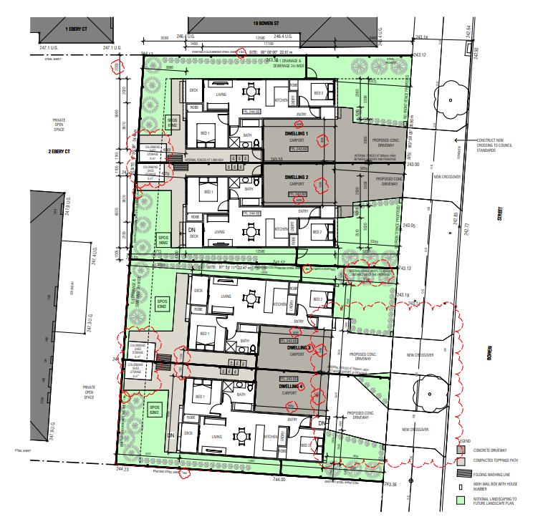

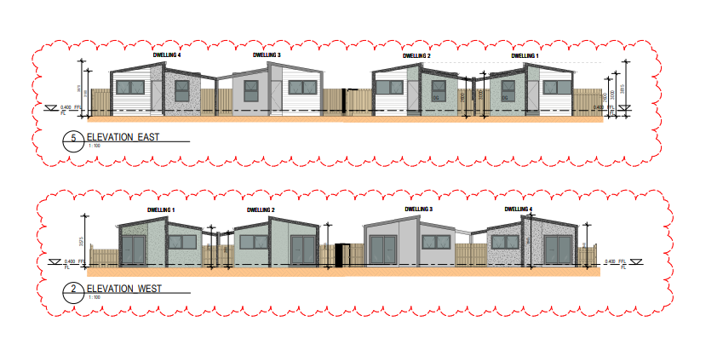

SITE AND SURROUNDING AREA

The subject site is located on the western side of Bowen Street, approximately 80m south of its intersection with Navarre Road. The rectangular shaped site measures approximately 793sqm in size and is currently vacant, cleared land.

The surrounding area is predominantly a residential area. Lot sizes in the area are mixed, with lots ranging from 400sqm to 1000+sqm in the immediate streetscape. Housing stock in the surrounding area is very mixed, with older weatherboard dwellings interspersed with newer brick never dwellings. Buildings are almost exclusively single storey in height.

The site has good access to community facilities, being located only 400m south of the St Arnaud CBD and within 200m of the nearest public open space area.

Bowen Street is a fully constructed road with concrete kerb and channel on both sides. Overhead powerlines are located along the western side of the road.

An aerial map is provided below. The subject site is outlined in orange.

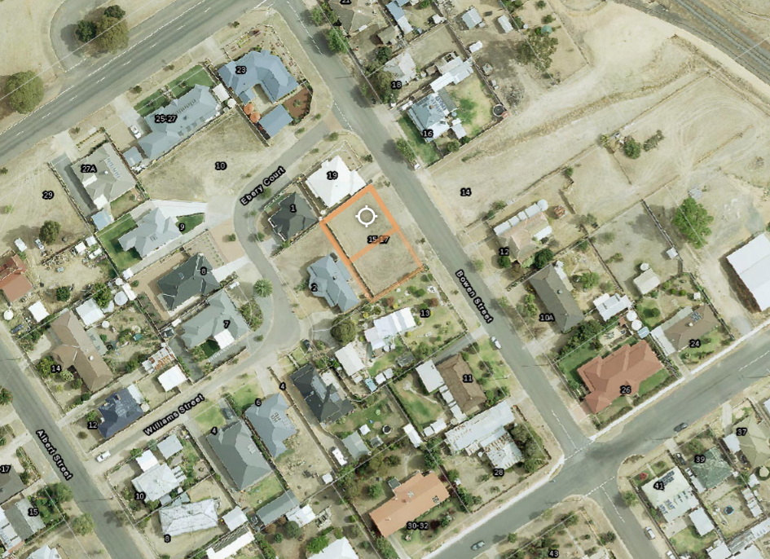

PERMIT HISTORY

- 5.2020.30.1 - Subdivision of land (2 lots) and associated works. This permit has not been completed.

REFERRALS

The following external referrals were undertaken:

Authority | Advice/ Response/Conditions | Report Response
Section 52 Referrals:
DELWP | No response received. | Noted. Considered to indicate no concerns.
GWM Water | No objection subject to conditions. | Noted. Conditions will be placed on permit.

The application was referred internally and comments received as below:

Internal Council Referrals | Advice/ Response/Conditions | Report Response
Infrastructure | No objection subject to conditions. | Noted. Conditions will be placed on permit.
Building | Building permit required | Noted. A note will be placed on the permit advising a building permit is required.

PUBLIC NOTIFICATION

The application was required to be advertised pursuant to Section 52 of the Planning and Environment Act 1987.

The following forms of advertising were undertaken:

- Notices sent to owners and occupiers of surrounding land;
- One sign was placed on the land;

OBJECTIONS

Council has received thirteen objections in response to advertising, along with one petition containing 38 signatures

The key issues raised in the objections can be summarised as follows:

- Dwelling tenure / anti-social behaviour
  - Socio-economic status of future occupants and possibility of anti-social behaviour
- Neighbourhood Character and design response
  - Appearance of buildings looks like ‘tin huts’
- Impact on property values
- Noise, safety and resident behaviour
- Crossovers and traffic concerns, including car parking
- Overdevelopment of the site

RESPONSE TO OBJECTIONS

Dwelling tenure / anti-social behaviour

Applicant Response
Many objections were raised regarding the type of future resident who might reside in the proposed dwellings. The concerns stem from their observations of the behaviour of residents of other forms of lower cost, medium density housing in the town.

This proposal can be distinguished from those other developments. It is the intention of the applicant that the proposed dwellings be used to house nurses and doctors associated with the East Wimmera Health Service, located approximately 1.2km to the north of the subject site. The dwellings have been designed with this in mind and there are ongoing conversations underway with the hospital to discuss future leasing options.

The permit applicant owns several investment properties (including a similar development opposite a hospital in another rural community). The permit applicant will not tolerate poor tenant behaviour or the destruction or mistreatment of his properties.

The Council will be aware that the use of the land for ‘Dwelling’ (including two or more dwellings on a lot) is a Section 1 land use. The land use has no associated condition, which means that it cannot be prohibited in any circumstance.

This means that the Council cannot (in absolutely any circumstances) restrict, control or prohibit the use of land for housing nor can it restrict, control or prohibit the nature of the occupancy.
It would be beyond power for Council to attempt to do this. Anti-social or criminal behaviours (regardless of the form of housing) is a matter for Victoria Police.

These concerns are not relevant to the town planning proceedings.
Responsible Authority Comments
It is a well-established planning principle that the socio-economic status of future occupants is not a relevant planning consideration.

Deputy President Dwyer in Hunt Club Commercial Pty Ltd v Casey CC (includes Summary) (Red Dot) held that “Town planning is not a panacea for all perceived social ills, nor is planning decision-making a forum for addressing all issues of social or community concern. At its heart, planning is about the use, development and protection of land. It has a spatial context that is primarily concerned with the fair, orderly, economic and sustainable use and development of land. Town planning does not involve itself in moral judgements”

This is expanded upon in VCAT case Nunan v Ballarat CC “During the hearing Mr Nunan raised a number of concerns about what he considered to be the social impacts of medium density housing within the street, which he submitted that the Tribunal was required to consider when assessing the neighbourhood character of the area… The broader question as to whether these properties are rented out or owner-occupied and the associated social impacts (whether real or perceived) is not a relevant consideration of this Tribunal.”

As such, in considering a planning permit application, planning officers cannot and should not base the planning decision based on perceived behaviour of potential future occupants. This is not a relevant planning consideration.

Regarding the applicant’s intention of using the proposed dwelling to house nurses and doctors for the St Arnaud Hospital; such intentions cannot be governed by planning or stipulated by permit conditions.

Neighbourhood Character and Design Response

Applicant Response
The subject site is located within General Residential Zone – Schedule 1 (GRZ1). The GRZ1 applies to ‘Northern Grampians General Residential Area’. There are no Neighbourhood Character objectives contained in the schedule to the zone.

Clause 15.01-5L ‘Neighbourhood Character – Northern Grampians’ contains the following relevant strategies:

- Provide landscaping that is integrated with the design of new development and complements the vegetation of the wider area and local character.
- Encourage new buildings to:
- Match prevailing setbacks.
- Address the street.
- Visually contribute to the streetscape character.
Bowen Street and the surrounding area has a varied front setback character and comprises mostly single storey brick or weatherboard dwellings (with some render emerging in newer dwellings). Dwellings typically have no front fence and landscaping is sparse, particularly among newer dwellings. Roof forms are typically pitched or hipped.

The proposed dwellings will be single storey in height and oriented to front the street. They will comprise grey timber-like slats, dark and light grey render which is respectful of both newer dwellings and older existing dwellings in the area. Proposed landscaping within the front setbacks will make a positive contribution to the streetscape. A landscape plan could be required as a condition on any permit to be issued.
Responsible Authority Comments
Firstly, as detailed above it is acknowledged that the subject site is well suited to higher density residential development and that infill development of the kind proposed is acceptable as a matter of policy. Council officers must also consider the proposals compliance with planning policies that require development to respond to the neighbourhood character of the area, including Clause 15.01-5S ‘Neighbourhood character’ which aims to recognise, support and protect neighbourhood character, cultural identity, and sense of place.

Objectors have raised concerns that the proposal is not in keeping with the neighbourhood character, in particular with regards to the built form which they have labelled as ‘tin hut’ style development.

The proposal has been designed to utilize a minimalist facade and contemporary materials. Given that building materials in the street are highly variable, with a mixture of weatherboard and brick homes, from more historic facades to modern brick veneer facades, the built form proposed is not considered to be so radically different as to represent an unacceptable design outcome.

Whilst the proposed development brings a density of housing not evident in the streetscape, the development has been carefully designed to minimize impacts on surrounding properties and respect the neighbourhood character as evidenced through the following design elements:

- The dwellings are setback more than 5m from the front boundary, to respect the prevailing building setbacks evident in the street.

- 47% of the site has been set aside for garden area, allowing for future landscaping which will help the buildings to ‘nestle in’ to their surrounds.

- The modest size of the buildings, the open carports and single storey height help reduce the visual bulk of the buildings.

- The buildings are setback from all side and rear boundaries, with no walls built on the boundary, to respect the existing spacing between buildings within the street and to minimise impacts onto abutting residential properties

- The total building height is approximately 4.1m which is well within the allowable 11m maximum height limit set out in the General Residential Zone provisions.

As set out in Tsalanidis v Bayside CC & Ors [2012] “The notion of respectful development does not mean that new development must be the same as what already exists. This is made clear in the Practice Note ‘Understanding Neighbourhood Character’ which says: Respecting character does not mean preventing change. The neighbourhood character standard is not intended to result in the replication of existing building stock or stop change. The discussion in the Practice Note goes on to say: Neighbourhood character is one of many objectives that must be met. Some areas will see significant changes as a result of new social and economic conditions, changing housing preferences and explicit housing policies. In these areas, it is important that respecting character is not taken too literally, as a new character will emerge in response to these new social and economic conditions.’ It is in this context, that the objectives of the scheme which call for development which is respectful of the neighbourhood character must embrace the outcome envisaged by other planning policies such as those which clearly encourage more intense development and increased densities in this location.”

In summary, the proposal clearly represents an intensification of development on the subject land, but on balance it is considered that the proposal, with its landscaping, setbacks, height, site coverage and built form represents an acceptable design response with regards to neighbourhood character.

Nevertheless, in order to meet some of the concerns raised by objectors the applicant has considered conditions on the permit which require a landscape plan and the treatment of the dwelling facades so that their material quality and appearance can be improved upon.

Traffic and parking concerns

Applicant Response
Clause 52.06-5 Car Parking requires one car parking space to be provided to each one or two bedroom dwelling and one visitor car parking space to be provided to each five dwellings.

The proposed development has a statutory car parking requirement of 4 car parking spaces (one to each dwelling). No visitor car parking spaces are required as the proposal is for less than 5 dwellings. That said, we note that here is also space for a second ‘tandem’ space in front of each car port (meaning that each dwelling has either twice the number of statutory car parking required).

The statutory car parking requirements of the development have been met.
Responsible Authority Comments
Clause 52.06 requirements have been met and the application was provided to Council’s Infrastructure Department which did not object or have any safety concerns.

Noise, Safety and Resident Behaviour

Applicant Response
Concerns about noise appear to be linked to other broader concerns about the nature of the tenancies. We have already explained that it is beyond power or the Council to impose conditions that relate to the occupancy of the dwellings.

Clause 55 of the Planning Scheme provides an assessment pathway for medium density housing. Clause 55.04-8 Noise impacts objectives says as follows:

- Noise impacts objectives
- To contain noise sources in developments that may affect existing dwellings.
- To protect residents from external noise.
Standard B24

- Noise sources, such as mechanical plant, should not be located near bedrooms of immediately adjacent existing dwellings.
- Noise sensitive rooms and secluded private open spaces of new dwellings and residential buildings should take account of noise sources on immediately adjacent properties.
- Dwellings and residential buildings close to busy roads, railway lines or industry should be designed to limit noise levels in habitable rooms.
A correct reading of this standard does not allow for an assessment of noise impacts by future residents on existing residents. The noise source contemplated by the standard is limited to noise caused by mechanical plant.

The Northern Grampians Shire Council General Local Law 2012 contains a number of Local Laws relating to community safety and amenity. Local Law 13 ‘Unsightly Land’ requires an owner or occupier to ensure that the land is not detrimental to the general amenity of the neighbourhood, is kept free of any graffiti, is not used in any manner that may cause a nuisance or become detrimental to the amenity of the neighbourhood and does not become a haven for vermin to establish on the land. Penalties apply for behaviour that does not comply with the above local law.

Anti-social or criminal behaviour (regardless of the form of housing) is a matter for Victoria Police, not the Council nor the planning system.
Responsible Authority Comments
The subject site and the abutting properties are in a residential zone; the amenity impacts from the site will be residential in nature, which given the General Residential Zoning of the land is expected and must be anticipated by neighbouring residents. There will be change with any intensification of land, however this change is not considered unacceptable given the zoning of the subject land and neighbouring land.

Overdevelopment

Applicant Response
As noted, the subject site is located within the General Residential Zone. The Purpose of the GRZ is to:
To encourage a diversity of housing types and housing growth particularly in locations offering good access to services and transport.

The subject site comprises two consolidated lots. It is proposed to construct four two bedroom, single storey dwellings across two lots. This represents a modest medium density development and it cannot be argued to be an overdevelopment of the site.

Moreover, the Northern Grampians Planning Scheme identifies the need for a greater diversity of housing within the municipality to accommodate the changing population demographic, namely the ageing population (Clause 02.03-6 Housing). The proposed development will assist in improving housing diversity in the area.
Responsible Authority Comments
Whilst the surrounding area does not have the scale of the proposed density of dwellings, the proposal is not considered an overdevelopment given the size of the land (nearly 800sqm) which is to house 4 two-bedroom dwellings, leaving 47% of the site as garden area.

Devaluation of property

Applicant Response
Several objections were raised regarding the potential of the proposed development to devalue surrounding properties. This issue has been considered in a number of VCAT cases. In Skunca v Mornington Peninsula SC [2004] VCAT 1690 (23 August 2004), the Tribunal made the following observations:

There was one ground in the original application for review that I have not mentioned. It was that the proposal would devalue the objectors' adjoining land. Apparently that matter was dealt with at a directions hearing when it was pointed out that this is not a valid planning consideration. If adjoining land is devalued because of detriment to its amenity, it is the detriment to the amenity that is considered in relation to town planning, not the resulting devaluation (in relation to which there is seldom, if ever, any evidence in any event).

We agree with the Tribunal that any perceived impact on the value of surrounding property is not a relevant town planning matter. Moreover, with regards to amenity, we note that the proposal complies with all of the objectives and most of the standards of Clause 55 where it concerns site layout and massing and amenity.
Responsible Authority Comments
It is a well-established planning principle that depreciation of land or property values resulting from development is not a relevant planning consideration. As stated in Skunca v Mornington Peninsula SC [2004] “If adjoining land is devalued because of detriment to its amenity, it is the detriment to the amenity that is considered in relation to town planning, not the resulting devaluation.” Therefore, property value is not, in itself, a planning consideration. Amenity impacts are relevant and the potential amenity impacts have been addressed earlier in this report.

Loss of privacy

Applicant Response
The proposed development meets the standard and objective of Clause 55.04-6 (Overlooking) and will not result in any unreasonable overlooking opportunities.
Responsible Authority Comments
Standard B22 is met with the proposed fence heights being 1.8 metres. In being only single storey dwellings with consistent fence heights, Council does not consider there to be grounds for privacy concerns.

Inadequate notification

Applicant Response
It is our understanding that public notification was given in accordance with the Planning and Environment Act 1987.
Responsible Authority Comments
Public notification was given was given in accordance with the Planning and Environment Act 1987 in way of direct letters to eight adjacent and neighbouring landowners, as well as with a sign on the land.

Heritage of 13 Bowen Street

Applicant Response
An objection was made regarding the potential impact of the proposed development on the existing dwelling at 13 Bowen Street, St Arnaud. The Victorian style cottage is identified on the Victorian Heritage Database as being of local significance. However, the dwelling is not affected by the Heritage Overlay and does not have statutory protection. As a result, it is not within the Council’s discretion to consider any potential impact on the heritage value of the adjoining dwelling at 13 Bowen Street.
Responsible Authority Comments
There is no statutory protection for 13 Bowen Street, however, the setback between the existing cottage at 13 Bowen Street and most southern dwelling of the proposal is considered a long enough distance for the transition of the built forms to be acceptable.

ASSESSMENT

The principal issues can be summarised as follows:

STRATEGIC JUSTIFICATION

The proposal generally complies with state and local planning policies, including the following provisions (as selected relevant):
- Clause 02.03-1 ‘Settlement’ aims to encourage development that supports the existing rural service role of St Arnaud and to encourage residential development within current township boundaries and particularly within the respective township centre and in proximity to the town sewerage scheme
- Clause 02.03-5 ‘Built form and Amenity’ aims to protect the neighbourhood character and heritage values of the shire’s towns.
- Clause 02.03-6 ‘Housing’ specifies that housing within the townships of the shire has traditionally comprised single dwellings on large lots. With a trend towards an ageing population, the household make-up and size are expected to also change. This is expected to result in a need for a greater diversity of housing to accommodate a changing population demographic. There is a mismatch between the changing structure of households and the available housing stock. This policy aims to:
  - Increase the diversity of housing styles and living opportunities throughout the municipality to ensure the attractiveness of the municipality as a place to live, work and invest.
  - Ensure the provision of a range of lot sizes and housing types in response to changes in family structure and an ageing population.
  - Encourage innovative forms of residential development such as those based on recreation and open space areas in suitable locations.
- Clause 11.02-1S ‘Supply of urban land’ aims to ensure a sufficient supply of land is available for residential, commercial, retail, industrial, recreational, institutional and other community uses. Planning for urban growth should consider:
  - Opportunities for the consolidation, redevelopment and intensification of existing urban areas.
  - Neighbourhood character and landscape considerations.
- or other uses with potential adverse off-site impacts.
- Clause 15.01-5S ‘Neighbourhood character’ aims to recognise, support and protect neighbourhood character, cultural identity, and sense of place.
- Clause 16.01-1S ‘Housing supply aims to facilitate well-located, integrated and diverse housing that meets community needs.
- Clause 16.01-2S ‘Housing affordability’ aims to deliver more affordable housing closer to jobs, transport and services.

Comments:

As detailed above, planning policy at state and local level expressly supports urban consolidation through the provision of medium density housing. Urban consolidation facilitates the efficient use of existing infrastructure and services, as well as provides much needed diversity and affordability to the housing market.

Unlike many areas of residential land, there are no heritage, vegetation or bushfire controls which affect the subject site. Therefore, there is strong policy support at state and local level for higher density residential development at the subject site.

ZONE

General Residential Zone

The site is located within the General Residential Zone (GRZ1) and the purpose of this zone is to:
- To implement the Municipal Planning Strategy and the Planning Policy Framework.
- To encourage development that respects the neighbourhood character of the area.
- To encourage a diversity of housing types and housing growth particularly in locations offering good access to services and transport.
- To allow educational, recreational, religious, community and a limited range of other non-residential uses to serve local community needs in appropriate locations.
Under the provisions of this zone, a planning permit is required to construct four dwellings on a lot.

This zone stipulates a maximum build height of 11m, to which the development complies.

This zone also requires a mandatory garden area provision of 35%. A garden area plan has been provided which shows a 47% garden area provision, again complaint with the requirements of this zone.

This zone stipulates that an application for multiple dwellings on a lot must be assessed against the Rescode design standards at Clause 55. A detailed clause 55 assessment is contained later in this report.

OVERLAYS

The site is not affected by any overlays.

PARTICULAR PROVISIONS

Clause 52.06 ‘Car Parking’

Clause 52.06 requires car parking be provided at the following ratio:

- One space for each one or two bedroom dwelling

All four dwellings contain only 2 bedrooms, and each dwelling is provided with one undercover car parking space. Dwellings 1 and 2 also have room for an additional tandem parking space in the driveway. This exceeds the requirements of Clause 52.06 and ensures that adequate on-site car parking is provided on accordance with the requirements of the Northern Grampian Planning Scheme.

Clause 55 ‘Rescode’

Clause 55 sets a framework for assessment, and it cannot be expected that all proposals will satisfy all Standards. The assessment therefore should focus on whether the objectives are met. As stated in VCAT case Paul Shaw & Associates Pty Ltd v Maroondah CC [2011] “Where minor ‘non-compliances’ are proposed with one or more Standards and their net affect has no adverse impact on third parties, such ‘non-compliances’ may be inconsequential relative to the overall outcome.”

The purpose of Clause 55 Two or more dwellings on a lot and Residential Buildings is to:

- achieve residential development that respects the existing neighbourhood character or which contributes to a preferred neighbourhood character
- encourage residential development that provides reasonable standards of amenity for existing and new residents
- encourage residential development that is responsive to the site and neighbourhood

A detailed assessment of the proposal against the Rescode requirements are below:

ATTACHMENT – CLAUSE 55 ASSESSMENT
55.02-1 Neighbourhood character objective | Standard B1 | Met | Comments
To ensure that the design respects the existing neighbourhood character or contributes to neighbourhood character.  To ensure that development responds to the features of the site and the surrounding area | The design response must be appropriate to the neighbourhood and the site.  The proposed design must respect the existing or preferred neighbourhood character and respond to the features of the site | Yes | Refer to comments earlier in this report regarding neighbourhood character.
55.02-2 Residential policy objective | Standard B2 | Met | Comments
To ensure that residential development is provided in accordance with any policy for housing in the State Planning Policy Framework and the Local Planning Policy Framework, including the Municipal Strategic Statement and local planning policies.  To support medium densities in areas where development can take advantage of public transport and community infrastructure and services | An application must be accompanied by a written statement to the satisfaction of the responsible authority that describes how the development is consistent with any relevant policy for housing in the State Planning Policy Framework and the Local Planning Policy Framework, including the Municipal Strategic Statement and local planning policies. | Yes | Refer to policy discussion earlier in this report.
55.02-3 Dwelling diversity objective | Standard B3 | Met | Comments
To encourage a range of dwelling sizes and types in developments of ten or more dwellings | Developments of ten or more dwellings should provide a range of dwelling sizes and types, including:  - Dwellings with a different number of bedrooms.  - At least one dwelling that contains a kitchen, bath or shower, and a toilet and wash basin at ground floor level. | NA | N/A
55.02-4 Infrastructure objective | Standard B4 | Met | Comments
To ensure development is provided with appropriate utility services and infrastructure.  To ensure development does not unreasonably overload the capacity of utility services and infrastructure. | Development should be connected to reticulated services, including reticulated sewerage, drainage, electricity and gas, if available. | Yes | Provision has been made for services and the application has been approved by GWM Water.
 | Development should not unreasonably exceed the capacity of utility services and infrastructure, including reticulated services and roads. | Yes
 | In areas where utility services or infrastructure have little or no spare capacity, developments should provide for the upgrading of or mitigation of the impact on services or infrastructure. | Yes
55.02-4 Integration with the street objective | Standard B5 | Met | Comments
To integrate the layout of development with the street | Developments should provide adequate vehicle and pedestrian links that maintain or enhance local accessibility. | Yes | All dwellings are oriented to Bowen Street and high front fencing is not proposed.
 | Development should be oriented to front existing and proposed streets | Yes
 | High fencing in front of dwellings should be avoided if practicable | NA
 | Development next to existing public open space should be laid out to complement the open space. | NA

55.03-1 Street setback objective | Standard B6 | Met | Comments
To ensure that the setbacks of buildings from a street respect the existing or preferred neighbourhood character and make efficient use of the site | Walls of buildings should be set back from streets the distance specified in Table B1 below.  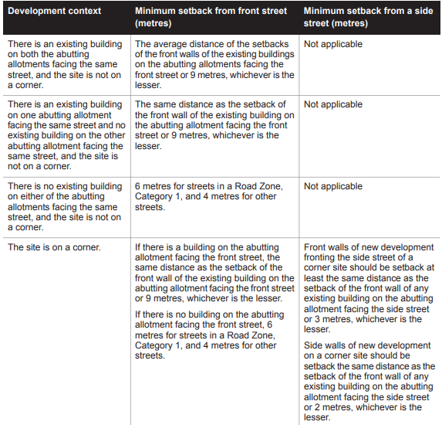 | Variation required | The northern allotment (19 Bowen St) has a 3m setback while the southern allotment (13 Bowen St) has a 14m setback from Bowen St. A variation to the standard is required. The proposed front setback ranges from 5.1m to 6.3m and is considered to represent an acceptable transition between the building setbacks on both abutting lots.
 | Porches, pergolas and verandahs that are less than 3.6 metres high and eaves may encroach not more than 2.5 metres into the setbacks of this standard. | NA
55.03-2 Building height objective | Standard B7 | Met | Comments
To ensure that the height of buildings respects the existing or preferred neighbourhood character | The maximum building height should not exceed 9 metres, unless the slope of the natural ground level at any cross section wider than 8 metres of the site of the building is 2.5 degrees or more, in which case the maximum building height should not exceed 10 metres. | Yes | The total building height is approximately 4.1m, well within the maximum height limit.
 | Changes of building height between existing buildings and new buildings should be graduated. | NA
55.03-3 Site coverage objective | Standard B8 | Met | Comments
To ensure that the site coverage respects the existing or preferred neighbourhood character and responds to the features of the site | The site area covered by buildings should not exceed 60 per cent | Yes | Site coverage is 43%, well within the maximum of 60%.
55.03-4 Permeability objective | Standard B9 | Met | Comments
To reduce the impact of increased stormwater run-off on the drainage system  To facilitate on-site stormwater infiltration | The site area covered by the pervious surfaces should be at least 20% of the site | Yes | Site permeability is 57% and therefore compliant. Stormwater management requirements will be addressed by way of permit conditions.
The stormwater management system should be designed to:
- Meet the current best practice performance objectives for stormwater quality as contained in the Urban Stormwater - Best Practice Environmental Management Guidelines (Victorian Stormwater Committee, 1999).
- Contribute to cooling, improving local habitat and providing attractive and enjoyable spaces.
55.03-5 Energy efficiency objective | Standard B10 | Met | Comments
To achieve and protect energy efficient dwellings and residential buildings  To ensure the orientation and layout of development reduce fossil fuel energy use and make appropriate use of daylight and solar energy | Buildings should be:  - Orientated to make appropriate use of solar energy  - Sited and designed to ensure that the energy efficiency of existing dwellings on adjoining lots is not unreasonably reduced | Yes | The development has been laid out in an appropriate manner noting the site constraints caused by the location of the road to the northeast of the site. Windows and SPOS areas will have adequate solar access.
 | Living areas and private open space should be located on the north side of the development if practicable | NA
 | Developments should be designed so that solar access to north-facing windows is maximised | Yes
 | Developments should be sited and designed to ensure that the performance of existing rooftop solar energy systems on dwellings on adjoining lots in a General Residential Zone, Neighbourhood Residential Zone or Township Zone are not unreasonably reduced. The existing rooftop solar energy system must exist at the date the application is lodged | Yes
55.03-6 Open space objective | Standard B11 | Met | Comments
To integrate the layout of the development with any public and communal open space provided in or adjacent to the development | If any public or communal open space is provided on site, it should:  - Be substantially fronted by dwellings, where appropriate  - Provide outlook for as many dwellings as practicable  - Be designed to protect any natural features on the site  - Be accessible and useable | NA | N/A
55.03-7 Safety objective | Standard B12 | Met | Comments
To ensure the layout of development provides for the safety and security of residents and property | Entrances to dwellings should not be obscured or isolated from the street and internal accessways | Yes | Dwelling entrances are visible from the street and rear yards are secure.
 | Planting which creates unsafe spaces along streets and accessways should be avoided | Yes
 | Developments should be designed to provided good lighting, visibility and surveillance of car parks and internal accessways | Yes
 | Private spaces within developments should be protected from inappropriate use as public thoroughfares | Yes
55.03-8 Landscaping objective | Standard B13 | Met | Comments
To encourage development that respects the landscape character of the neighbourhood  To encourage development that maintains and enhances habitat for plants and animals in locations of habitat importance  To provide appropriate landscaping  To encourage the retention of mature vegetation on the site | The landscape layout and design should:  - Protect any predominant landscape features of the neighbourhood  - Take into account the soil type and drainage patterns of the site  - Allow for intended vegetation growth and structural protection of buildings  - In locations of habitat importance, maintain existing habitat and provide for new habitat for plants and animals  - Provide a safe, attractive and functional environment for residents | Yes | A detailed landscape plan will be required by way of permit condition.
 | Development should provide for the retention or planting of trees, where these are part of the character of the neighbourhood | N/A
 | Development should provide for the replacement of any significant trees that have been removed in the 12 months prior to the application being made | NA
 | The landscape design should specify landscape themes, vegetation (location and species), paving and lighting | Yes
55.03-9 Access objective | Standard B14 | Met | Comments
To ensure the number and design of vehicle crossovers respects the neighbourhood character | The width of accessways or car spaces should not exceed:  - 33% of the street frontage, or  - if the width of the street frontage is less than 20m, 40% of the street frontage | Yes | The 12m total crossover width meets the 33% maximum.
 | No more than one single-width crossover should be provided for each dwelling fronting a street | Yes
 | The location of crossovers should maximize the retention of on-street car parking spaces | Yes
 | The number of access point to a road in a Road Zone should be minimised | NA
 | Developments must provide access for service, emergency and delivery vehicles | N/A
55.03-10 Parking location objective | Standard B15 | Met | Comments
To provide convenient parking for resident and visitor vehicles  To protect residents from vehicular noise within developments | Car parking facilities should:  - Be reasonably close and convenient to dwellings and residential buildings  - Be secure  - Be well ventilated if enclosed | Yes | Car parking is close, convenient and undercover
 | Shared accessways or car parks of other dwellings and residential buildings should be located at least 1.5m from the windows of habitable rooms. This setback may be reduced to 1m where there is a fence at least 1.5m high or where window sills are at least 1.4m above the accessway | Yes

55.04-1 Side and rear setbacks objective | Standard B17 | Met | Comments
To ensure that the height and setback of a building from a boundary respects the existing or preferred neighbourhood character and limits the impact on the amenity of existing dwellings | A new building not on or within 200mm of a boundary should be set back from side or rear boundaries 1 metre, plus 0.3 metres for every metre of height over 3.6 metres up to 6.9 metres, plus 1 metre for every metre of height over 6.9 metres. | Yes | All walls are setback more than the required amount.
 | Sunblinds, verandahs, porches, eaves, fascias, gutters, masonry chimneys, flues, pipes, domestic fuel or water tanks, and heating or cooling equipment or other services may encroach not more than 0.5m into the setbacks of this standard | NA
 | Landings having an area of not more than 2sqm and less than 1m high, stairways, ramps, pergolas, shade sails and carports may encroach into the setbacks of this standard | NA
55.04-2 Walls on boundaries objective | Standard B18 | Met | Comments
To ensure that the location, length and height of a wall on a boundary respects the existing or preferred neighbourhood character and limits the impact on the amenity of existing dwellings | A new wall constructed on or within 200mm of a side or rear boundary of a lot or a carport constructed on or within 1 metre of a side or rear boundary of a lot should not abut the boundary for a length of more than:  - 10 metres plus 25 per cent of the remaining length of the boundary of an adjoining lot, or  - Where there are existing or simultaneously constructed walls or carports abutting the boundary on an abutting lot, the length of the existing or simultaneously constructed walls or carports,  whichever is the greater. | NA | No walls are proposed to be built on the boundary.
 | A new wall or carport may fully abut a side or rear boundary where slope and retaining walls or fences would result in the effective height of the wall or carport being less than 2 metres on the abutting property boundary. | NA
 | The height of a new wall constructed on or within 200mm of a side or rear boundary or a carport constructed on or within 1 metre of a side or rear boundary should not exceed an average of 3.2 metres with no part higher than 3.6 metres unless abutting a higher existing or simultaneously constructed wall. | NA
55.04-3 Daylight to existing windows objective | Standard B19 | Met | Comments
To allow adequate daylight into existing habitable room windows | Buildings opposite an existing habitable room window should provide for a light court to the existing window that has a minimum area of 3sqm and minimum dimensions of 1m clear to the sky. The calculation of the area may include land on the abutting lot | Yes | All habitable windows open to a suitably sized light court
 | Walls or carports more than 3m in height opposite an existing habitable room window should be set back from the window at least 50% of the height of the new wall if the wall is within a 55º arc from the centre of the existing window. The arc may be swung to within 35º of the plane of the wall containing the existing window  Where the existing window is above ground floor level, the wall height is measured from the floor level of the room containing the window  Refer to Diagram B2 | Yes
55.04-4 North facing windows objective | Standard B20 | Met | Comments
To allow adequate solar access to existing north-facing habitable room windows | If a north-facing habitable window of an existing dwelling is within 3m of a boundary on an abutting lot, a building should be setback from the boundary 1m, plus 0.6m for every metre of height over 3.6m up to 6.9m, plus 1m for every metre of height over 6.9m, for a distance of 3m from the edge of each side of the window.  A north-facing window is a window with an axis perpendicular to its surface oriented north 20 degrees west to north 30 degrees east.  Refer to Diagram B3 | NA | N/A
55.04-5 Overshadow open space objective | Standard B21 | Met | Comments
To ensure buildings do not significantly overshadow existing secluded private open space | Where sunlight to secluded private open space of an existing dwelling is reduced, at least 75%, or 40sqm with minimum dimension of 3m, whichever is the lesser area, of the secluded private open space should receive a minimum of five hours of sunlight between 9am and 3pm on 22 September | Yes | No proposed building within 3m of private open space.
 | If existing sunlight to the secluded private open space of an existing dwelling is less than the requirements of this standard, the amount of sunlight should not be further reduced | Yes
55.04-6 Overlooking objective | Standard B22 | Met | Comments
To limit views into existing secluded private open space and habitable room windows | A habitable room window, balcony, terrace, deck or patio should be located and designed to avoid direct views into the secluded private open space of an existing dwelling within a horizontal distance of 9m (measured at ground level) of the window, balcony, terrace, deck or patio. Views should be measured within a 45º angle from the plane of the window or perimeter of the balcony, terrace, deck or patio, and from a height of 1.7m above the floor level | Yes | The four dwellings are single storey and the land slopes from the back to the front of the site. The windows close to boundaries do not provide overlooking as the fencing will be 1.8 metres high.
 | A habitable room window, balcony, terrace, deck or patio with a direct view into a habitable room window of an existing dwelling within a horizontal distance of 9m (measured at ground level) of the window, balcony, terrace, deck or patio should be either:  - offset a minimum of 1.5m from the edge of one window to the edge of the other  - have sill heights of at least 1.7m above floor level  - have fixed, obscure glazing in any part of the window below 1.7m above floor level  - have permanently fixed external screens to at least 1.7m above floor level and be no more than 25% transparent | Yes
 | Obscure glazing in any part of the window below 1.7m above floor level may be openable provided that there are no direct views as specified in this standard | NA
 | Screens used to obscure a view should be:  - perforated panels or trellis with a maximum of 25% openings or solid translucent panels  - permanent, fixed and durable  - designed and coloured to blend with the development | NA
55.04-7 Internal views objective | Standard B23 | Met | Comments
To limit views into the secluded private open space and habitable room windows of dwellings and residential buildings within a development | Windows and balconies should be designed to prevent overlooking of more than 50% of the secluded private open space of a lower-level dwelling or residential building directly below and within the same development | NA | The proposal does not contain multi-storey dwelling levels.
55.04-8 Noise impacts objective | Standard B24 | Met | Comments
To contain noise sources in developments that may affect existing dwellings  To protect residents from external noise | Noise sources, such as mechanical plant, should not be located near boundaries of immediately adjacent existing dwellings | Yes | Noise sources such as mechanical plant equipment will not be located near noise sensitive rooms and secluded private open spaces. Therefore, the objectives of the Standard will be met.
 | Noise sensitive rooms and secluded private open spaces of new dwellings and residential buildings should take account of noise sources on immediately adjacent properties | Yes
 | Dwellings and residential buildings close to busy roads, railway lines or industry should be designed to limit noise levels in habitable rooms | Yes

55.05-1 Accessibility objective | Standard B25 | Met | Comments
To encourage the consideration of the needs of people with limited mobility in the design of developments | The dwelling entries of the ground floor of dwellings and residential buildings should be accessible or able to be easily made accessible to people with limited mobility. | Yes  No NA | Floor levels are raised 400mm above the ground from the carport level, steps are design to provide access through the porch and from the deck to the landscaped secluded private open space rear area. There is sufficient space on the site for each dwelling’s entry to be upgrade with a ramp should it be ever required.
55.05-2 Dwelling entry objective | Standard B26 | Met | Comments
To provide each dwelling or residential building with its own sense of identity | Entries to dwellings and residential buildings should:  - be visible and easily identifiable from streets and other public areas  - provide shelter, a sense of personal address and a transitional space around the entry | Yes | Each dwelling is a detached residence with only the porch abutting, that is clearly identifiable from the street leading down from the driveway.
55.05-3 Daylight to new windows objective | Standard B27 | Met | Comments
To allow adequate daylight into new habitable room windows | A window in a habitable room should be located to face:  - an outdoor space or a light court with a minimum area of 3sqm and minimum dimension of 1m clear to the sky, not including land on an abutting lot, or  - a verandah provided it is open for at least one third its perimeter, or  - a carport provided it has two or more open sides and is open for at least one third of its perimeter | Yes | To comply with this Standard habitable room windows on all dwellings face an outdoor space clear to the sky and exceed the minimum requirements set by the standard.
55.05-4 Private open space objective | Standard B28 | Met | Comments
To provide adequate private open space for the reasonable recreation and service needs of residents | A dwelling or residential building should have private open space:  - an area of 40sqm, with one part secluded at the side or rear with a min area of 25sqm, a min dimension of 3m and convenient access from a living room, or  - a balcony of 8sqm with a min width of 1.6m and convenient access from a living room, or  - a roof-top area of 10sqm with a min width of 2m and convenient access from a living room | Yes | Each dwelling has 90-120 sqm which well exceeds the standard.
55.05-5 Solar access to open space objective | Standard B29 | Met | Comments
To allow solar access into the secluded private open space of new dwellings and residential buildings | The private open space should be located on the north side of the dwelling or residential buildings | No | The main section of the secluded private open space was unable to be located on the north side of the dwelling due to the unfavourable orientation of the site. Notwithstanding this, the SPOS receives good solar access for half of the day.  Additionally, as a form of offset to the poor orientation, the SPOS proposed for each dwelling was increased in area and in minimum width to provide an increased amount of SPOS that receives sunlight.
 | The southern boundary of secluded private open space should be set back from any wall on the north of the space at least (2 + 0.9h) metres, where ‘h’ is the height of the wall  Refer to Diagram B29 | Yes
55.05-6 Storage objective | Standard B30 | Met | Comments
To provide adequate storage facilities for each dwelling | Each dwelling should have convenient access to at least 6m³ of externally accessible, secure storage space | Yes | Each dwelling has an external shed providing at least 6 cubic metres of storage area.

55.06-1 Design detail objective | Standard B31 | Met | Comments
To encourage design detail that respects the existing or preferred neighbourhood character | The design of buildings, including:  - Facade articulation and detailing,  - Window and door proportions,  - Roof form, and  - Verandahs, eaves and parapets,  should respect the existing or preferred neighbourhood character. | Yes | It is submitted that the designs have considered the existing neighbourhood character. This includes; similar articulation and sizing to the surrounding dwellings, single storey dwellings with pitched roofs, habitable rooms facing the street, neutral tones as seen in the neighbourhood, and an evident distinction between the porch and the house.  To address concerns raised in the Notification process, a permit condition is recommended which requires the enhancement of the front facades, using an improved materiality, which complements the surrounding area to the satisfaction of Council.  The garages are built into the dwelling footprint and so provide a less obtrusive option.
 | Garages and carports should be visually compatible with the development and the existing or preferred neighbourhood character | Yes
55.06-2 Front fences objective | Standard B32 | Met | Comments
To encourage front fence design that respects the existing or preferred neighbourhood character | The design of front fences should complement the design of the dwelling and any front fences on adjoining properties | NA | The proposal does not include a front fence, and therefore the standard is not generally relevant.
 | A front fence within 3m of a street should not exceed:  - Streets in a Road Zone – 2m  - Other Streets – 1.5m | NA
55.06-3 Common property objective | Standard B33 | Met | Comments
To ensure that communal open space, car parking, access lanes and site facilities are practical, attractive and easily maintained  To avoid future management difficulties in areas of common ownership | Developments should clearly delineate public, communal and private areas | Yes  No NA | No communal space except for the shared proposed crossover.
 | Common property, should be functional and capable of efficient management | Yes  No NA
55.06-4 Site service objective | Standard B34 | Met | Comments
To ensure that site services can be installed and easily maintained  To ensure that site facilities are accessible, adequate and attractive | The design and layout of dwellings and residential buildings should provide sufficient space (including easements where required) and facilities for services to be installed and maintained efficiently and economically | Yes | Dwellings are separated apart therefore, there is sufficient space and facilities for services to be installed and maintained efficiently and economically. Bins will be kept within the SPOS area of each unit and therefore not visible. Each dwelling will have an individual mail box easily accessible by Australia Post. The locations of the bin storage and the letter boxes are indicated on the application plans.
 | Bin and recycling enclosures, mailboxes and other site facilities should be adequate in size, durable, waterproof and blend in with the development | Yes
 | Bin and recycling enclosures should be located for convenient access | Yes
 | Mailboxes should be provided and located for convenient access | Yes

CLAUSE 65
The application is generally consistent with the decision guidelines of Clause 65.01 – Approval of an application.

CONCLUSION
The proposal is considered to accord with the relevant decision guidelines of the Northern Grampians Planning Scheme. It is recommended that a Planning Permit is issued subject to the following conditions.

Amended Plans

- Before the development starts, amended plans to the satisfaction of the Responsible Authority must be submitted to and approved by the Responsible Authority. When approved, the plans will be endorsed and will form part of the permit. The plans must be drawn to scale with dimensions. The plans must be generally in accordance with the submitted plans but modified to the satisfaction of the Responsible Authority to show:

- enhancement of the front facades all dwellings, using an improved materiality and articulation, to the satisfaction of the Responsible Authority.

Endorsed Plans

- The development as shown on the endorsed plans must not be altered without the written consent of the Responsible Authority. All buildings and works must be constructed and or undertaken in accordance with the endorsed plans to the satisfaction of the Responsible Authority, and must be completed to the satisfaction of the Responsible Authority prior to the occupation of the development. All buildings and works must be located clear of any easements or water and sewer mains unless written approval is provided by the relevant authority.

Landscape Plan
- Prior to the commencement of any works, a landscape plan must be submitted to and approved by the Responsible Authority. When approved the plan will form part of the permit. The landscape plan must include:

- details of surface finishes of pathways and driveways;
- a planting schedule of all proposed trees, shrubs and ground covers, including botanical names, common names, pot sizes, size at planting, sizes at maturity, and quantities of each plant.
- Provision of canopy trees.

Completion and Maintenance of Landscaping Works

- Prior to the occupation of the buildings commencing all landscape works forming part of the approved Landscape Plans must be completed to the satisfaction of the Responsible Authority. The landscaping shown on the approved landscape plan must be maintained to the satisfaction of the Responsible Authority for 18 months from the practical completion of the landscaping. During this period, any dead, diseased or damaged plants or landscaped areas are to be repaired or replaced during the period of maintenance and must not be deferred until the completion of the maintenance period.

Internal Access Ways and Car Parking

- Prior to the occupation of the development, the areas set aside for the parking of vehicles and access lanes as shown on the approved plans must to the satisfaction of the Responsible Authority be constructed of concrete. Car spaces must be maintained and kept available for these purposes at all times.

Infrastructure Conditions

Construction Phase

- Soil erosion control measures must be employed throughout the construction stage of the development to control sediment entering the downstream stormwater system to the satisfaction of the Responsible Authority.

- Appropriate measures must be implemented throughout the construction stage of the development to rectify and/or minimise mud, crushed rock or other debris being carried onto public roads or footpaths from the subject land, to the satisfaction of the Responsible Authority.

- The applicant must ensure that dust suppression is undertaken in the form of constant water spraying or other natural based proprietary dust suppressant to ensure that dust within the site does not cause a nuisance to surrounding properties to the satisfaction of the Responsible Authority.
Entry Works:

- Access to all units must be provided to Bowen Street via an all-weather concrete driveway to the satisfaction of the Responsible Authority.

- Any new vehicular crossing to the subject land from the road shall be constructed at a location and of a size and standard satisfactory to the Responsible Authority. The vehicle crossings must be constructed at the applicant’s expense to provide ingress and egress to the site to the satisfaction of the Responsible Authority.

- Prior to commence any works on the road reserve area, the developer must obtain a Works Within Road Reserve Permit from Councils Infrastructure Department. Works must not commence until Councils Infrastructure team has given consent to conduct the works within the road reserve. Note: A copy of this permit can be obtained from Councils website or customer service team

- Any new vehicular crossing shall have satisfactory clearance to any side-entry pit, power or Telecommunications pole, manhole cover or marker, or street tree. Any relocation, alteration or replacement required shall be in accordance with the requirements of the relevant Authority and shall be at the applicant’s expense.

- All disused or redundant vehicle crossings must be removed and reinstated (kerb and channel) to the satisfaction of the Responsible Authority.
Councils Existing Assets:

- Before any of the works onsite commences, the owner or developer must submit to the Responsible Authority a written report and photos of any prior damage to public infrastructure. Listed in the report must be the condition of kerb & channel, footpath, seal, street lights, signs and other public infrastructure fronting the property and abutting at least one property either side of the site. Unless identified with the written report, any damage to infrastructure post construction will be attributed to the subdivision of the site. The owner or developer of the subject land must pay for any damage caused to the Councils assets/Public infrastructure caused as a result of the development or use permitted by this permit.

Stormwater Drainage

- Stormwater from the properties must be drained to the satisfaction of the Responsible Authority.

- All drainage discharge from the buildings and impervious surfaces of the development must be collected on site and dissipated to pre-development levels prior to discharging to the legal point of discharge to the satisfaction of the Responsible Authority.

- Before any of the works commence a properly prepared drainage discharge plan with computations to the satisfaction of the responsible authority must be submitted to and approved by the Responsible Authority. When approved, the plans will be endorsed and will then form part of the permit. The plans must be drawn to scale with dimensions. The information and plan must include:

  - Details of how the works on the land are to be drained and retarded.
  - Locations of any existing stormwater drainage infrastructure within the easement
  - Locations and sizes of underground pipe drains and pits, conveying stormwater to the legal point of discharge.
Before the use begins and/or the buildings are occupied all works constructed or carried out must be in accordance with those plans to the satisfaction of the Responsible Authority.

Emissions and Discharges during Construction:

- The developer must restrict emissions and discharges from any construction sites within the land in accordance with the best practice environmental management techniques and guidelines contained in the Environment Protection Authority publications for sediment pollution control and Environmental Guidelines for major construction sites to the satisfaction of the Responsible Authority

GWM Water Conditions

- The owner/applicant must provide individual ymetered water services to each dwelling in accordance with GWMWater’s requirements

- The owner/applicant must provide GWMWater with an updated drainage plan for each dwelling submitted by a qualified plumber.

- The owner/applicant must ensure a minimum horizontal clearance of 1.0m is maintained from any GWMWater assets to proposed structures in accordance with Section 148 of the Water Act 1989.

- The owner/applicant must ensure the construction will place no additional load on any GWMWater water of sewer assets. Where footings or piers are proposed for the foundations of structures, they must extend to a minimum depth to the angle of repose to the invert level of the trench of any water or sewer mains, Upon request, developer must demonstrate that no external load is applied to GWMWater’s assets. Driven piles are not permitted.

- The owner/applicant must enter a Build Over Easement Agreement with GWMWater for the proposed storage sheds which encroach on the sewerage easement at the rear of the property
Permit Expiry – Development

- Development expires if:
- The development or any stage of it does not start within two (2) years of the date of this permit; or
- The development or any stage of it is not completed within four (4) years of the date of this permit; or

The responsible authority may extend the periods referred to if a request is made in writing before the permit expires or within six months afterwards (for a request to extend the time to commence the development) or twelve months after the permit expires (for a request to extend the time to complete the development).

Building Approvals

This permit does not constitute any authority to carry out any building works or occupy the building or part of the building unless all relevant building permits are obtained. The works hereby approved must accord with the requirements of the Building Act 1993, Building Regulations 2018 and Building Code of Australia 2019.

