Western Victoria Online Peer Action Group
In partnership with the Victorian Advocacy League for Individuals with Disability present

Stories of our town
OUR LIVES IN STAWELL
By ____________

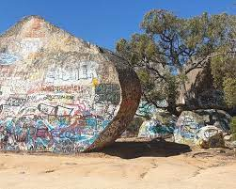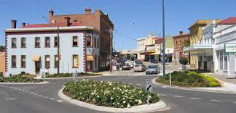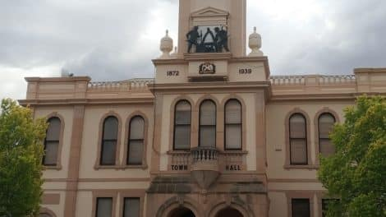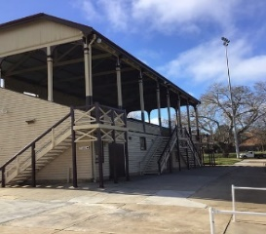

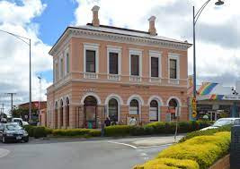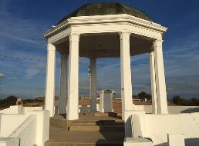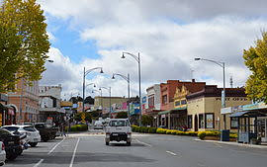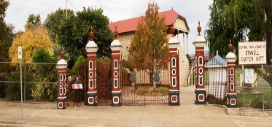

Western Victoria Online Peer Action Group
In partnership with the Victorian Advocacy League for Individuals with Disability present
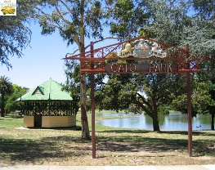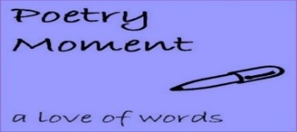

Stories of our town
OUR LIVES IN STAWELL
Tell us about your life and experiences in Stawell. What does your community mean to you? What adventures have you had in Stawell? Share your favourite memories through story.

About the Project
- Stories can be up to but no more than 300 words.

- Plain or lined story guides are available.

- This is an accessible project for all community members so if you would like to submit your story in an alternative format to the written word such as recording your voice, video, song or drawing, please do. We can help you to enter your story in any format. Representation matters and we would like to see more writers and hear more stories from people with disabilities, however this a community wide writing project for all.

- Email candace@vaild.org.au or submit your writing through the Facebook page - Stories of Our Town- Our lives in Stawell.

- We are available to host workshops (in person and online) to get stories submitted. Please email us your interest.

- We would love to host a spoken word event online or in person, to celebrate and share the stories that are submitted and produce an online publication as well.

Please join us to celebrate our town.
Email: candace@valid.org.au, 0439187030, jana@valid.org.au or call 0417939556

